E-Commerce Conversion Funnel & Performance Analysis — Project Report
This project analyzes the complete e‑commerce user journey from website visit to purchase, focusing on funnel performance, marketing efficiency, user behaviour patterns, and revenue drivers. The Power BI dashboard enables stakeholders to monitor KPIs, identify drop‑offs, optimize campaigns, and make data‑driven growth decisions.

Objectives
• Evaluate each stage of the conversion funnel
• Measure campaign performance and revenue contribution
• Understand user behaviour and engagement trends
• Identify leak‑points affecting conversions
• Support strategic marketing and UX optimization decisions

Dataset & Tools
Data Sources:
• Web analytics events
• Orders & transactions
• Session‑level user behaviour data
Tools & Techniques:
• Power BI
• Power Query for ETL & cleaning
• Data modeling (Star Schema)
• DAX for KPI & funnel calculations

Methodology
The analysis was structured across three layers:
1) Conversion Funnel Analysis — mapping user movement across stages such as Homepage, Product Page, Add‑to‑Cart, Checkout, and Purchase.
2) Revenue & Marketing Insights — evaluating traffic sources, campaign performance, CPA, and revenue distribution.
3) User Behaviour Analysis — exploring engagement depth, device trends, events, and high‑value interactions.

Dashboard Page 1 — Funnel & Core KPIs
This page provides an overview of business health and funnel performance, displaying metrics such as Total Sessions, Total Orders, Cost per Acquisition, Average Order Value, and Session Duration. The funnel visualization highlights the progressive drop‑off across stages from Product Page to Purchase.
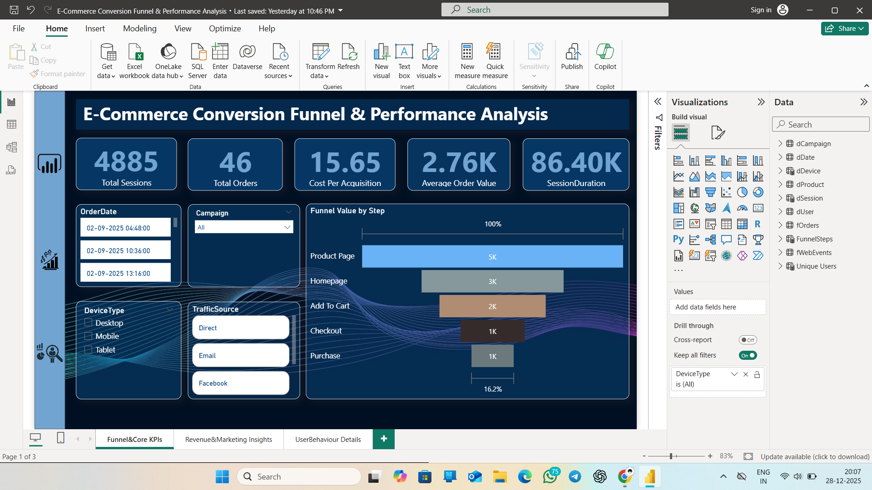
Key Insights:
• Highest traffic observed at Product Page stage
• Major drop‑off between Add‑to‑Cart and Checkout
• Purchase conversion rate indicates optimisation opportunity

Dashboard Page 2 — Revenue & Marketing Insights
This page analyses campaign‑wise and channel‑wise performance. The revenue donut chart breaks down revenue contributions across traffic sources, while the line chart tracks order quantity trends by date. The bar chart compares conversion rates across marketing campaigns.
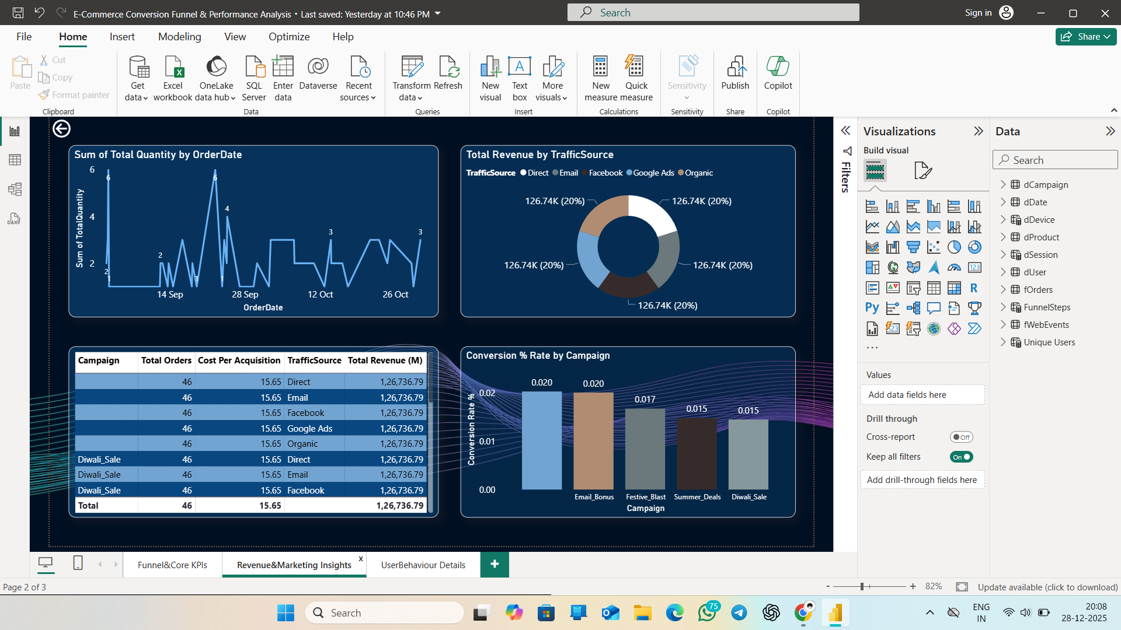
Key Findings:
• All traffic channels contribute meaningful revenue share
• Campaigns such as Email Bonus yield the highest conversion efficiency
• Seasonal campaigns show moderate but steady performance

Dashboard Page 3 — User Behaviour Details
This deep‑dive page focuses on user interaction behaviour, revealing high‑value sessions, device‑type usage, and category‑wise engagement. It highlights the highest‑revenue campaign, purchase count, and total event activity.
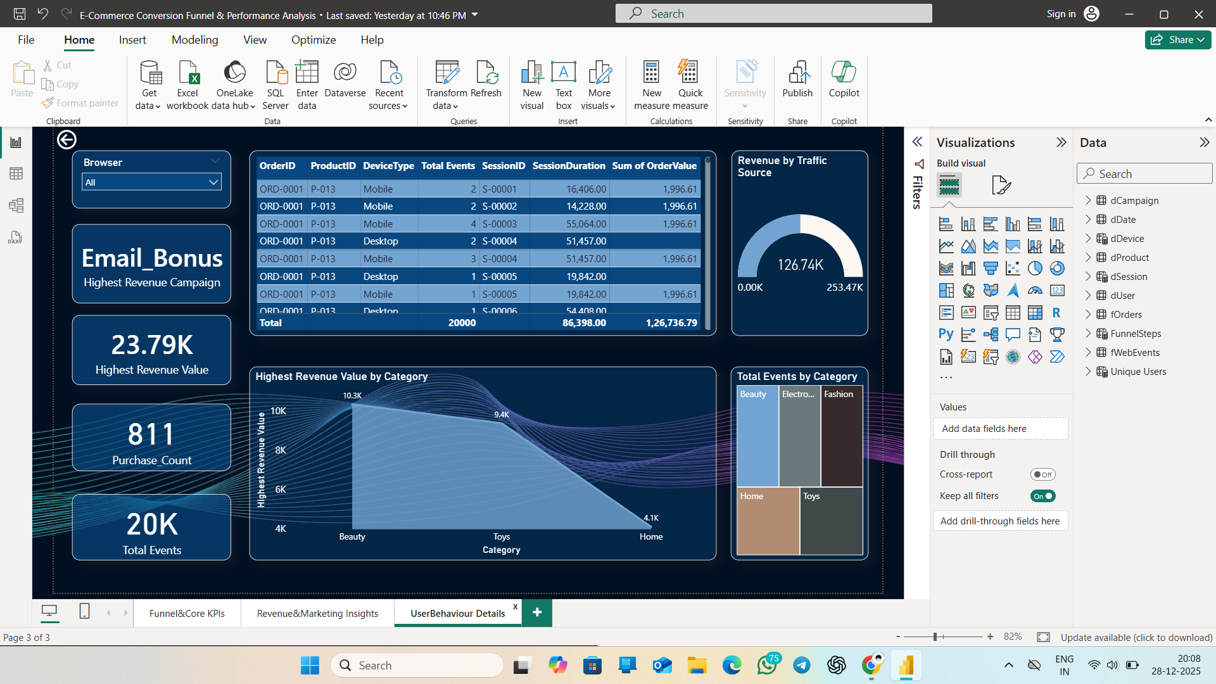
Insights Derived:
• Mobile users account for a large share of high‑value interactions
• Beauty and Toys categories generate the highest revenue
• Total events correlate strongly with engagement depth

Overall Insights & Recommendations
• Reduce friction between Add‑to‑Cart and Checkout (UX improvement, guest checkout, faster payment options)
• Invest more in high‑ROI campaigns such as Email Bonus
• Retarget cart‑abandonment users with remarketing flows
• Prioritise mobile‑first design enhancements
• Continue monitoring behavioural event trends for optimisation

Limitations & Future Enhancements
Limitations:
• Dependent on tracking and attribution accuracy
• Behavioural context outside platform not fully captured
Future Enhancements:
• Cohort retention and lifetime value modelling
• Predictive conversion and churn analytics
• Integration of real‑time streaming event data

